**How to add General ledger from Xero (or any other software) to VT Transactions in 2 minutes (I will use Xero for these instructions)**

# Step 1. Preparing the Names of accounts for both software

This step is long, but you need to do it once for every company.

1. Download or copy the **chart of** **accounts** from the bookkeeping software and VT **to Excel**
2. Make a table with those accounts where accounts from **Xero correspond** with accounts from **VT** (Note: in VT accounts have two objects. Add ‘: ‘ (colon, space) between them.
3. Save the file

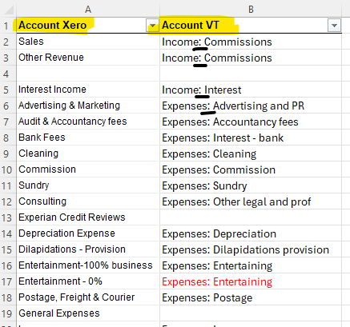

# Step 2. Preparing a file for VT Transactions

1. Save General ledger. (Xero → Accounting → Reports → General ledger Detail)
   1. Check that all accounts ticked
   2. Choose dates
   3. Select columns (You need only 4 columns: Account, Description, Debit, Credit.)
   4. Choose grouping (Group by None)
   5. Update

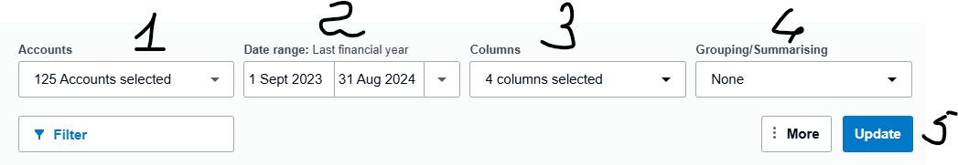

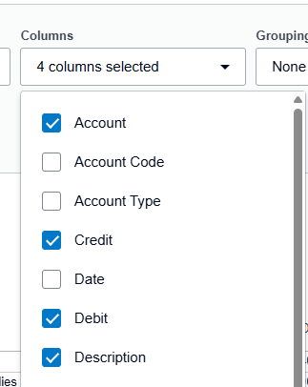 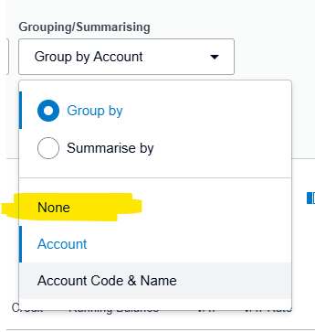

1. Export **General ledger** from Software that you use for bookkeeping in **Excel** format.

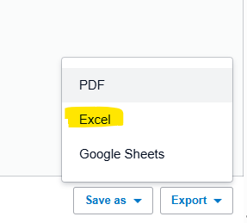

1. You can save a template or use every time new Excel file.

I’ve saved Excel file with all info that I need

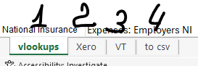

* 1. VLOOKUP – it’s a table with **accounts from Step 1**

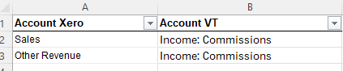

* 1. Xero – copied General ledger from Xero

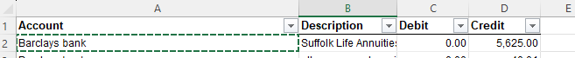

* 1. VT – information that we need for VT
     1. Copy General ledger from Xero page (only 4 columns, in case you’ve saved more) or use the table in Xero page.
     2. Add column ‘Account VT’ and map the accounts with VLOOKUP formula (if you need help with VLOOKUP, just ask me or find it on YouTube 😁)

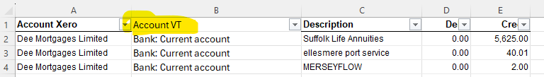

* 1. To CSV – it’s our data that we need to download to VT transactions.
* You can copy the table (insert Values) here or straight to the prepared .csv file,
* don’t use headers (names of the columns),
* save as a new CSV

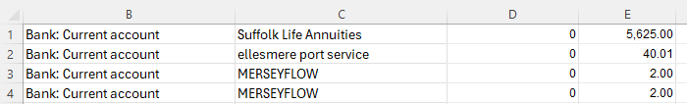

# Step 3. VT Transactions

1. Open Transactions → Journal → Import

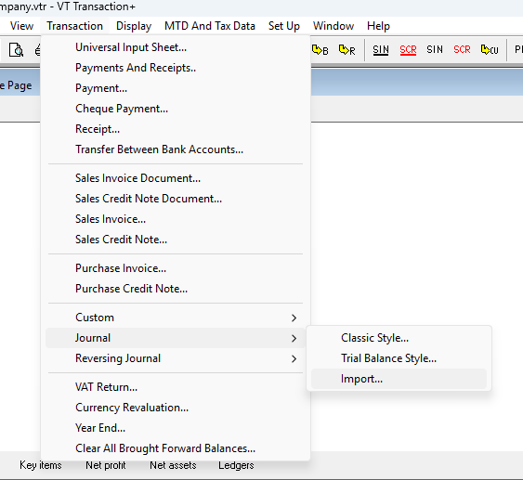

1. Now follow the next steps

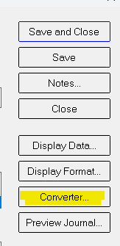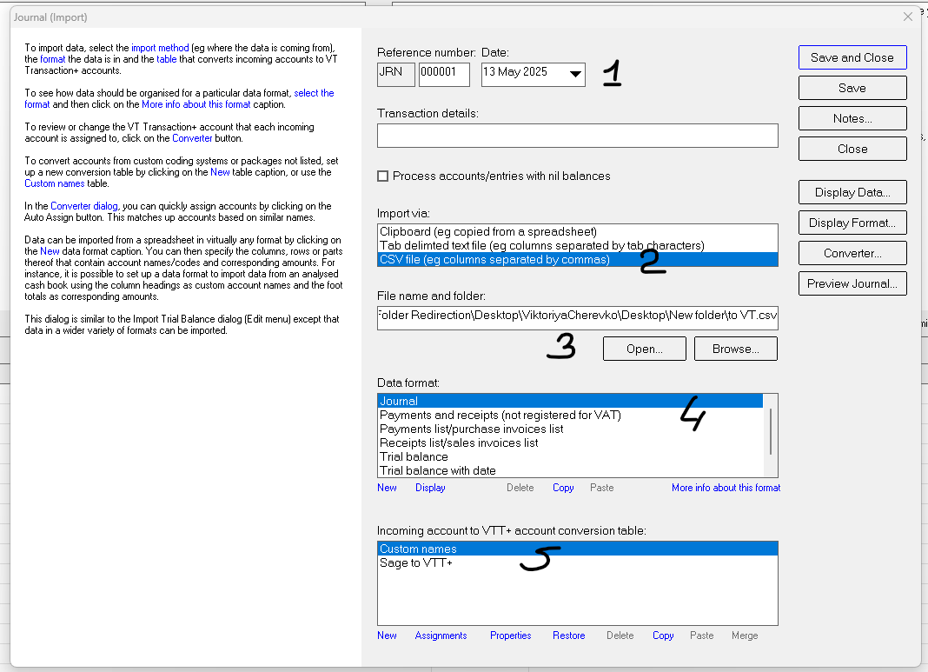

* 1. Choose the date
  2. Import via: **CSV file**
  3. Chose the file that should be downloaded
  4. Data format: Journal
  5. Conversion table: **Custom names**
  6. Also, you can add ‘Transaction details’ (Optional)

1. Press ‘Converter’
2. You’ll see a table where the names of accounts that was taken from file are in ‘Code or name’ column,

‘VTT+ account’ is an account that VT choose to allocate to

1. Check if all accounts are allocated.

* Choose ‘Unassigned accounts’ and choose the proper account manually
* Don’t forget to add this account to your file (Step 1) for future
* Press ‘OK’

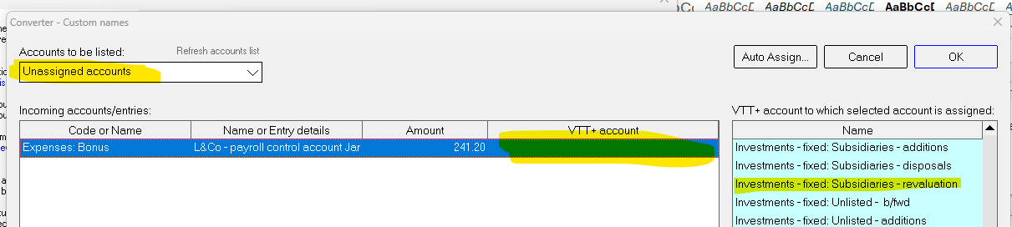

1. Press ‘Save and Close’

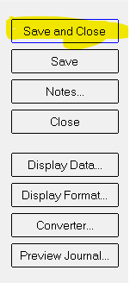

1. You can see one Journal entry in VT



1. **In case of changes, you can easily delete this journal and download a new one**